**SMART WATER SYSTEM**

**OBJECTIVE :**

Pollution of water is one of the main threats in recent times as drinking water is getting contaminated and polluted. The polluted water can cause various diseases to humans and animals, which in turn affects the life cycle of the ecosystem. If water pollution is detected in an early stage, suitable measures can be taken and critical situations can be avoided. To make certain the supply of pure water, the quality of the water should be examined in real-time. Smart solutions for monitoring of water pollution are getting more and more significant these days with innovation in sensors, communication, and Internet of Things (IoT) technology. In this paper, a detailed review of the latest works that were implemented in the arena of smart water pollution monitoring systems is presented. The paper proposes a cost effective and efficient IoT based smart water quality monitoring system which monitors the quality parameters uninterruptedly. The developed model is tested with three water samples and the parameters are transmitted to the cloud server for further action.

**BLOCK DIAGRAM:**

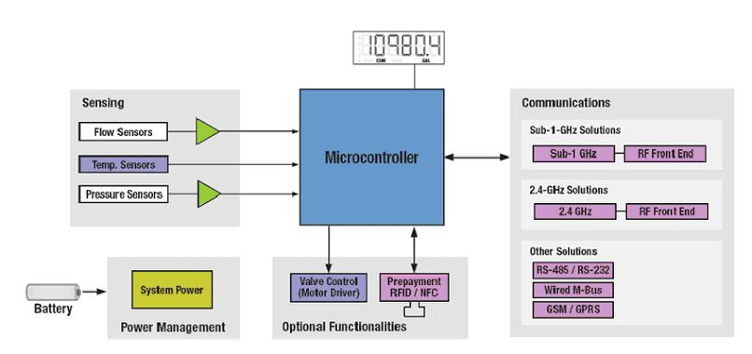

It represents the design and deployment of IoT sensors to monitor water consumption in public places.

1. **Public Places**: The locations where you'll install the IoT sensors, such as parks and gardens.
2. **IoT Sensors**: These sensors (IoT devices) are responsible for monitoring water consumption. They collect data and transmit it to the IoT data processing component.
3. **IoT Data Processing**: This component processes and validates the data received from the sensors before storing it.
4. **IoT Data Storage**: Data is stored securely, ensuring its availability for analysis and retrieval.
5. **Data Sharing Platform**: This platform provides access to real-time water consumption data through a user-friendly interface.
6. **User Interface & Visualization**: The interface where public users can access and visualize water consumption data. This could be a web application or a mobile app.
7. **Public Users**: The end-users, which can include the general public, park authorities, or environmental organizations.

We use the ESP8266 ,flow sensor, Ultrasonic Distance Sensors, Water Level Sensors, Water Quality Sensors etc…

**INTEGRATION APPROACH :**

The successful implementation of this project relies on a well-thought-out integration approach that brings together IoT sensors, data collection, and sharing components seamlessly.the IoT platform, careful configuration to receive, process, and store sensor data is essential. This step forms the foundation for the data-sharing platform integration, where user-friendly APIs and robust authentication mechanisms are created to facilitate data access.In essence, a well-executed integration approach ensures that this project effectively promotes water conservation by providing real-time water consumption data to the public while maintaining data security and system reliability

**CONCLUTION:**

In summary, this project utilizes a variety of sensors, including flow meters, pressure sensors, and water level sensors, to monitor water consumption in public places. These sensors provide real-time data on how much water is being used, allowing for accurate tracking and analysis. By implementing these sensors and making this data publicly available, we aim to promote water conservation, raise awareness, and encourage responsible water usage in our communities. This project underscores the importance of technology in addressing environmental challenges and contributing to the sustainable management of our valuable water resources